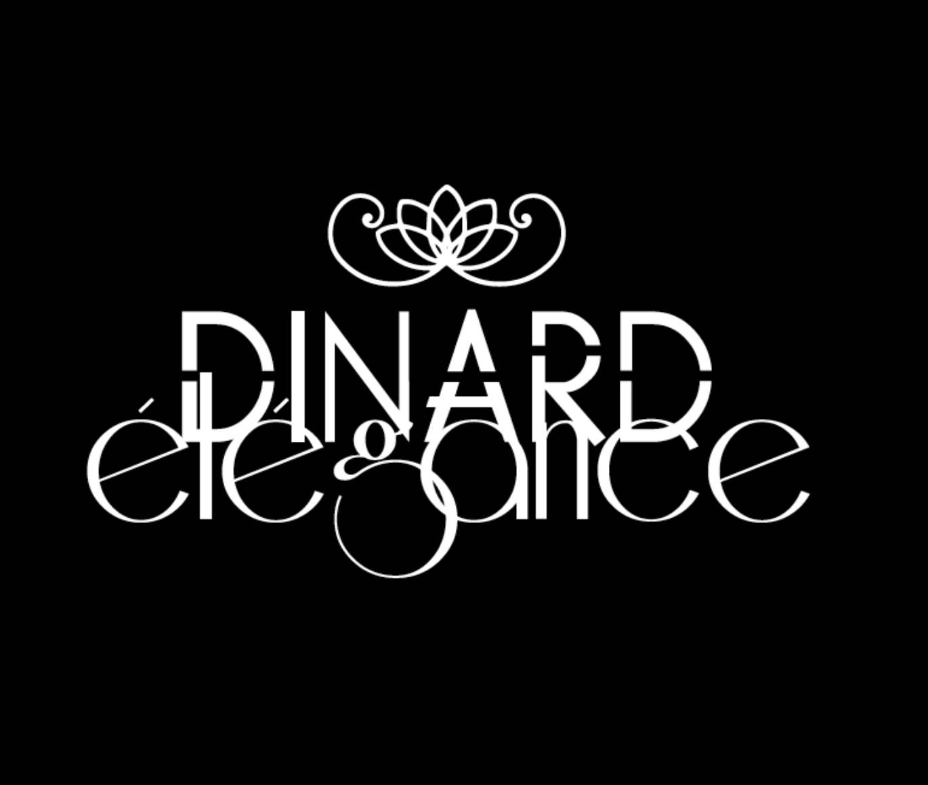
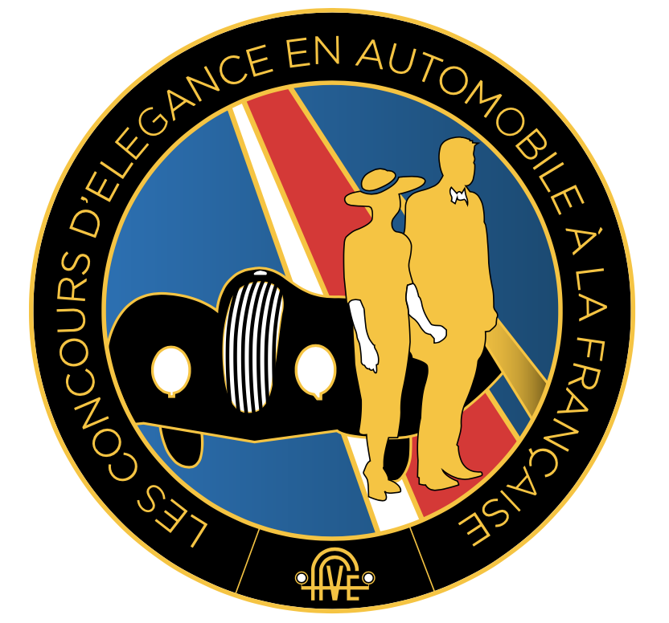

FFVE Charter
for (French style) Concours d’Elégance

The Fédération Française des Véhicules d’Epoque (FFVE) has published a Charter which a selection of events must respect to justify the label of "Concours d´Elégance en Automobile à la Française". To obtain such label, the organiser had to present a request for approval to a specialized FFVE commission.
Dinard is officially part of FFVE’s 2021 Concours d’Elégance Programme.

Classification of vehicles:
Vehicles entered in the Concours must be over 30 years old. According to FFVE and FVA recommendations, 4 main classes are defined:
Class 1: After 1960 – Post Classic
Class 2: from 1945 to 1960 - Classic
Class 3: from 1931 to 1941 – Post Vintage
Class 4: before 1931 – Vintage, Edwardian and veteran cars

Trophies
A “silver” FFVE trophy will be awarded to the best team in each class. The team that has obtained the maximum number of points, overall, will be awarded the Grand Prix d' Excellence (Best of Show), a "gold" trophy. The team coming second in this class will be upgraded to first in class and win the class silver trophy.
In the event of a tie for first place in a given class, the trophy goes to the oldest car. If the two tied cars are from the same year, the one with a FIVA identity card will win.

A Prix de la Ville de Dinard and a Prix Spécial du Jury will also be awarded.

The organizer as well as sponsors can enter cars, but these will be not classified with the others and be presented in a special category.
Friendship and selfless passion should always prevail, and no claim will be received.
Judges
The jury, composed of up to eight judges, includes representatives of the FFVE, elected officials (generally the town Mayor), experts in historic vehicles, fashion design or fine arts.
The cars will be shown to the judges before the concours.
FFVE regulations asks each judge to allocate a theoretical maximum total of 60 points to each team in the following way:
1. Condition (preservation or restoration) and authenticity of the car (0 to 20 points)
2. Elegance, “look” of the car (0 to 20 points)
3. Presentation and elegance of the team (0 to 20 points)

Team Presentation
The order of presentation starts with the youngest car (most recent) and ends with the oldest.
The presentation by a couple is not an obligation (cars in French Concours d’Elégance a century ago were often presented by a single woman driver).
Sketches are not encouraged.
Period clothes consistent with the style and time of the car are recommended even if up to date but elegant wear is perfectly acceptable: “elegance is dateless”. Jewelry and accessories like gloves or hats fitting the car style and period can be a plus. As it was fashionable in the heydays of French-style Concours d'Elégance, a dog can be part of the team.
A bellboy will open the lady’s door and the couple may move on the stage to greet the judges and the audience.

This text is an abstract from FFVE’s Charter of French Concours d’Elégance events

